

**Excel Assignment - 14**

Dataset:

https://docs.google.com/spreadsheets/d/1-Zo A4gnlLOQxpU8qgpkTJPJCS8cQBmNzKVirJ_Ow0w/edit?usp=sharing

Use the above dataset and answer the following questions. Assume that a gang is trying to loot Diamonds and Soft drinks being exported from India

1. How much Diamonds were looted from Chennai Port Trust?

Answer: 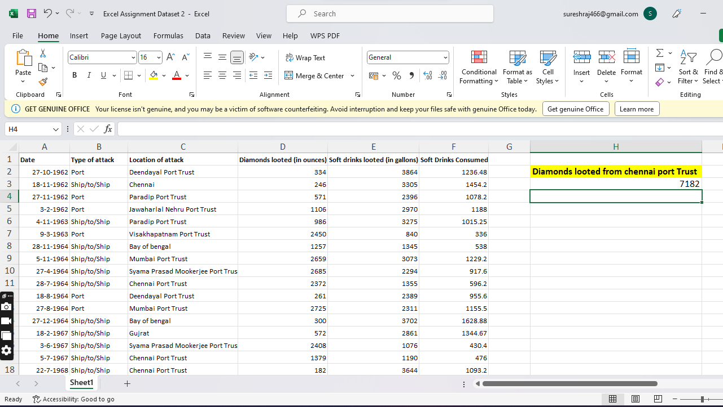

2. How many Ships were looted near Paradip Port Trust and Chennai Port Trust?

Answer: 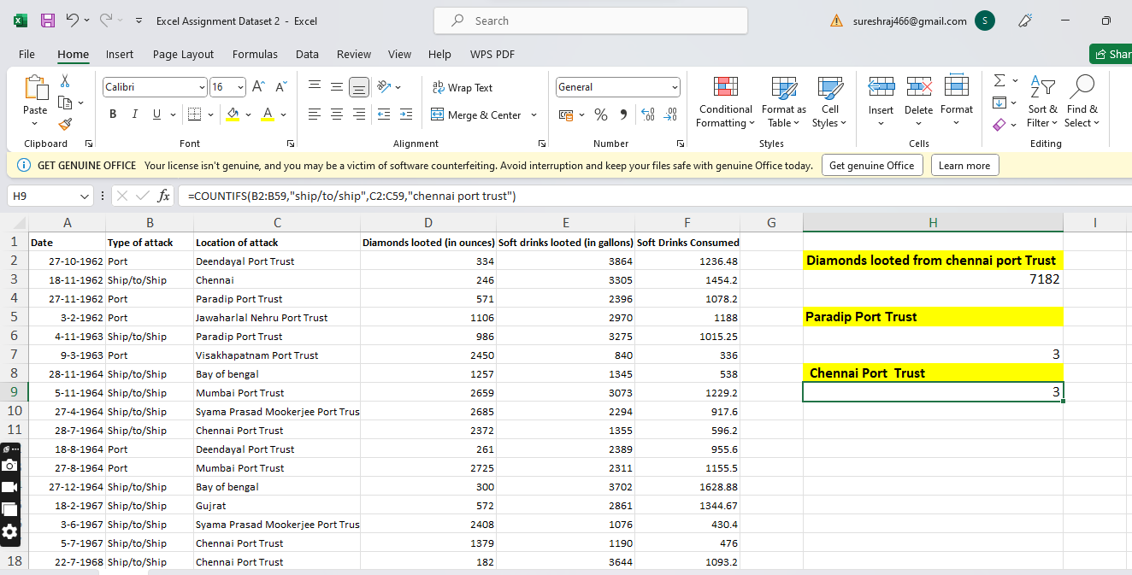

3. What is the sum total of Diamonds looted from the V.O. Chidambarnar port trust?

Answer:

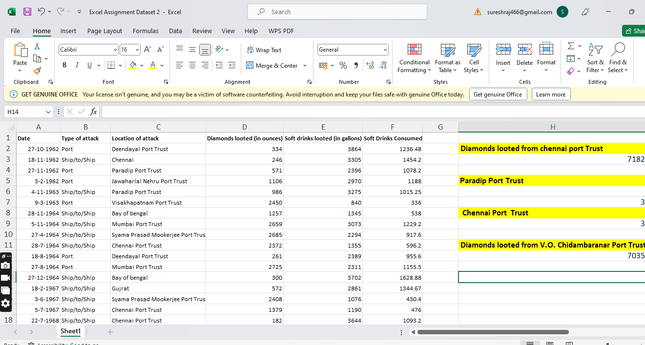



4. What is the average amount of Diamonds and Soft drinks looted?

Answer: 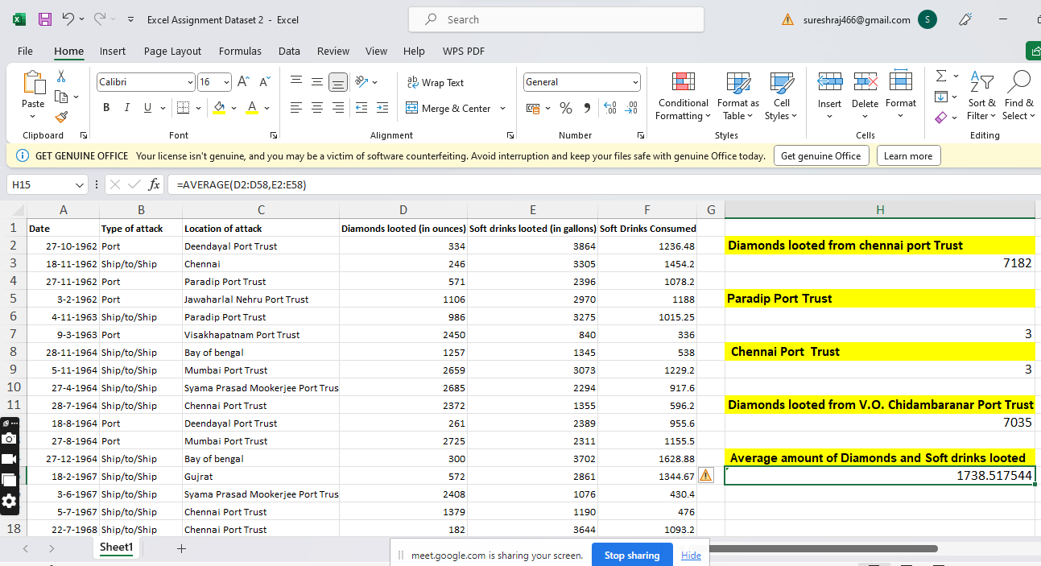

5. What is the ratio of soft drinks drunk to soft drinks looted?

Answer: 